Lab 3 – Dirty Cow Lab

1 Overview

Created a VM with SEEDUbuntu 12.04 and made an administrator account with my name:
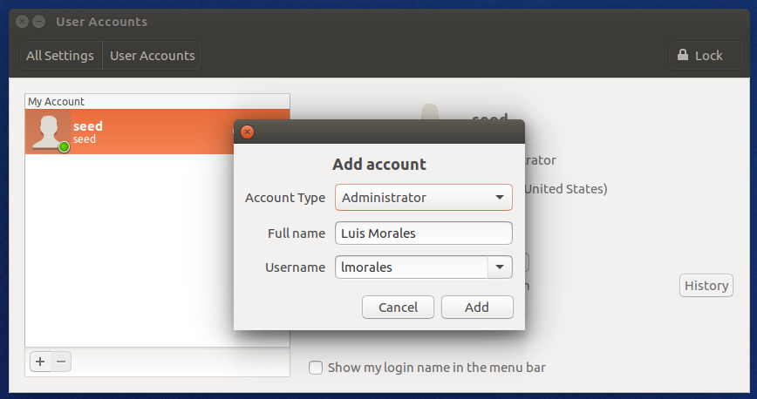
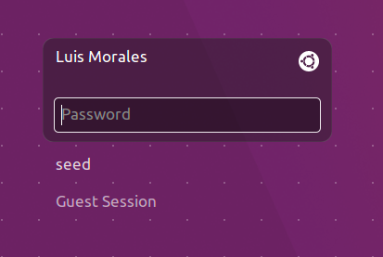

2 Task 1: Modify a Dummy Read-Only File
I created a new document and put random text in the document as stated in the lab. I then viewed the contents of the document and checked the mode of the document and was denied writing permission:
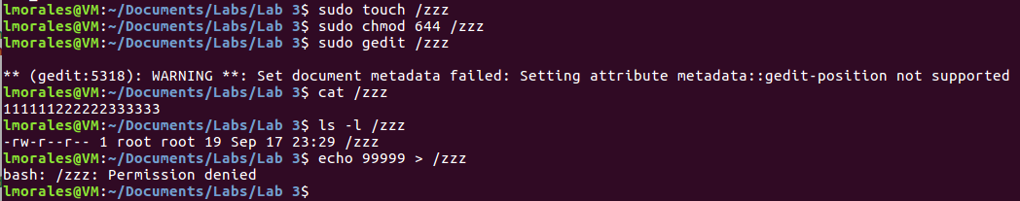
cow_attack.c was compiled (with some errors)and ran for a few seconds.
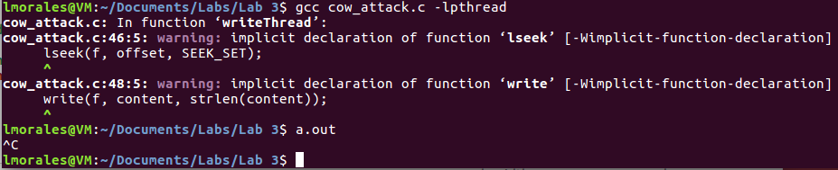
That didn’t work so to make sure I was trying to edit the correct file I added more text to the target file
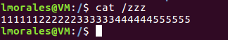
I also added a library to be included with the code:
#include <unistd.h>, this got rid of the implicit declaration errors I was getting, but still no successful attack.

If it were to be achieved it would be exploiting ther kernel’s handing of copy-on-write memory mapping. Normally when you mmap a file with map private, any write to the memory creates a private copy and does not modify the original file. This exploit races two threads, one keeps calling the kernel to discard the memory pages and the other writes directly to memory and access the process’s memory space. This tricks the kernel into writing to the original file, even though it’s mapped read-only and opened with O_RDONLY.

3 Task 2: Modify the Password File to Gain the Root Privilege

We created a standard user account named Charlie
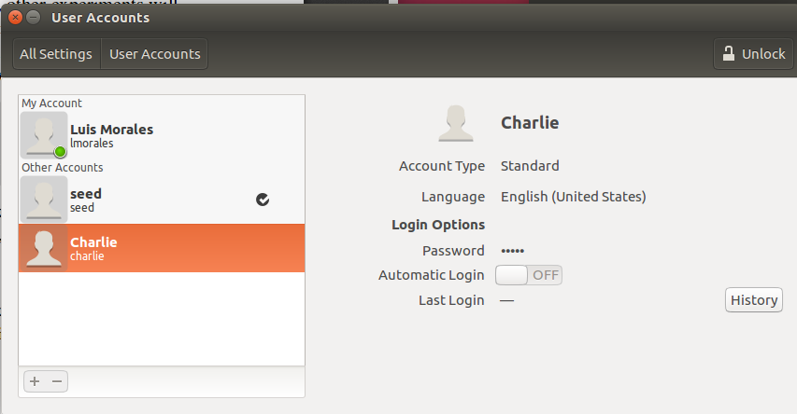
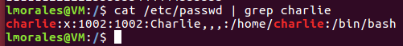

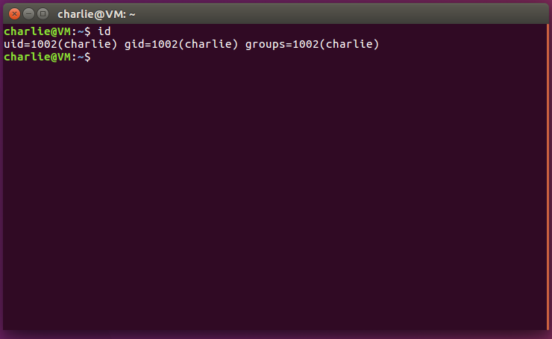sudo
I set the target text to something a little more specific “charlie:x:1002:1003:Charlie” and the substitution text to “charlie:x:0000:1003:charlie”. This gave Charlie root access.
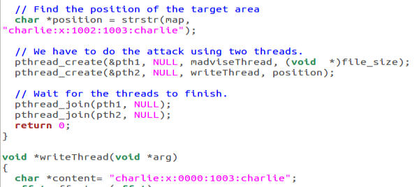

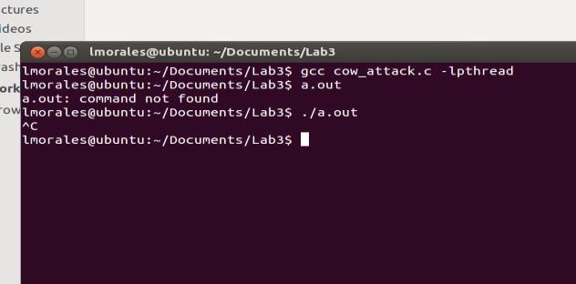

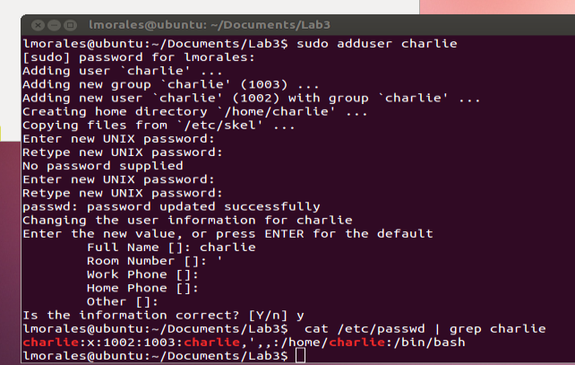
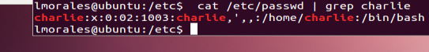
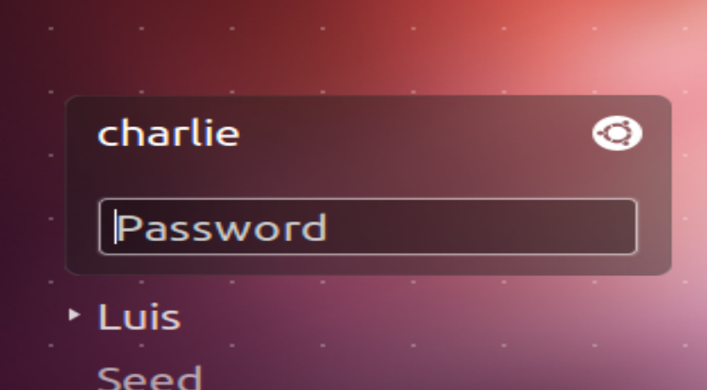
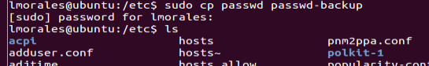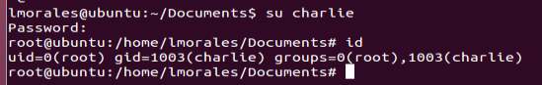

The su command in linux allows a user to switch accounts, in this case to a user that has been granted root access. After installing the correct version of Ubuntu things went smoothly.

